Name: Arpit Mahalle
Day 22 assignment output screenshots
Challenge 1:
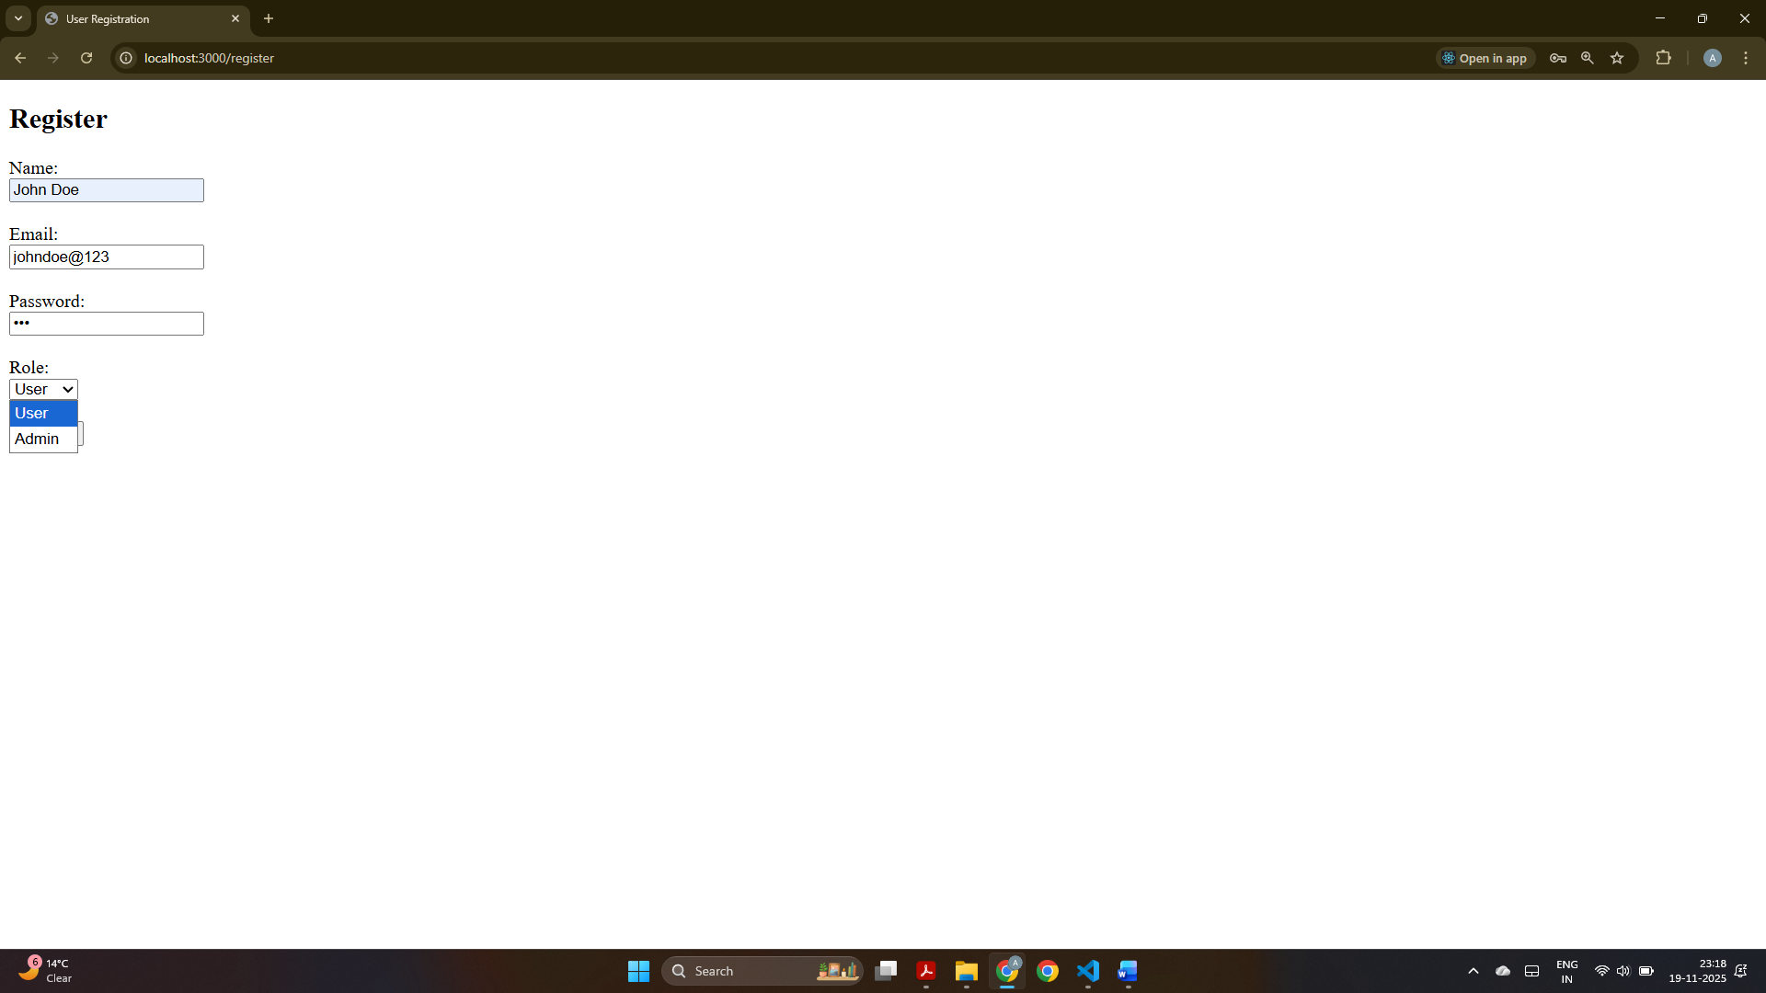
This output shows the browser displaying the registration form where the user enters name, email, password, and selects a role before submitting.

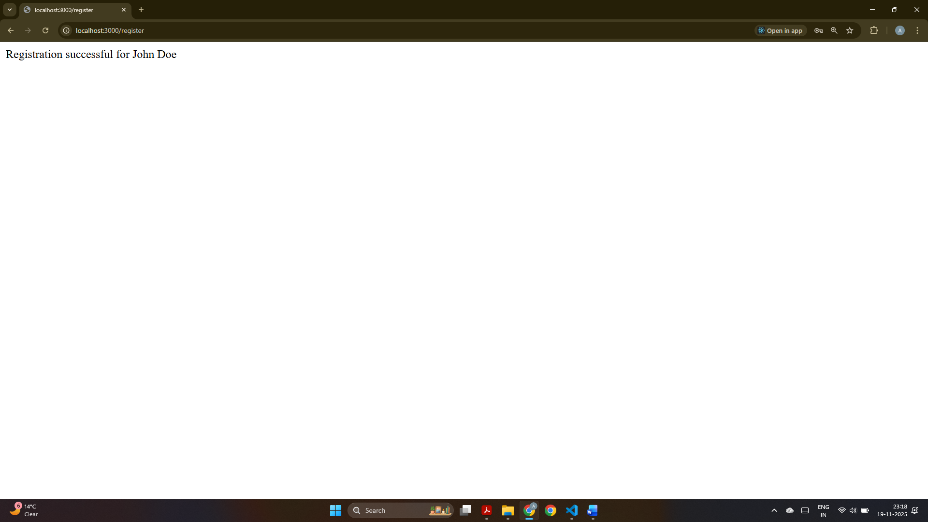
This screenshot confirms that the registration was successful, displaying the message “Registration successful for John Doe” after submitting the form.
Challenge 2:
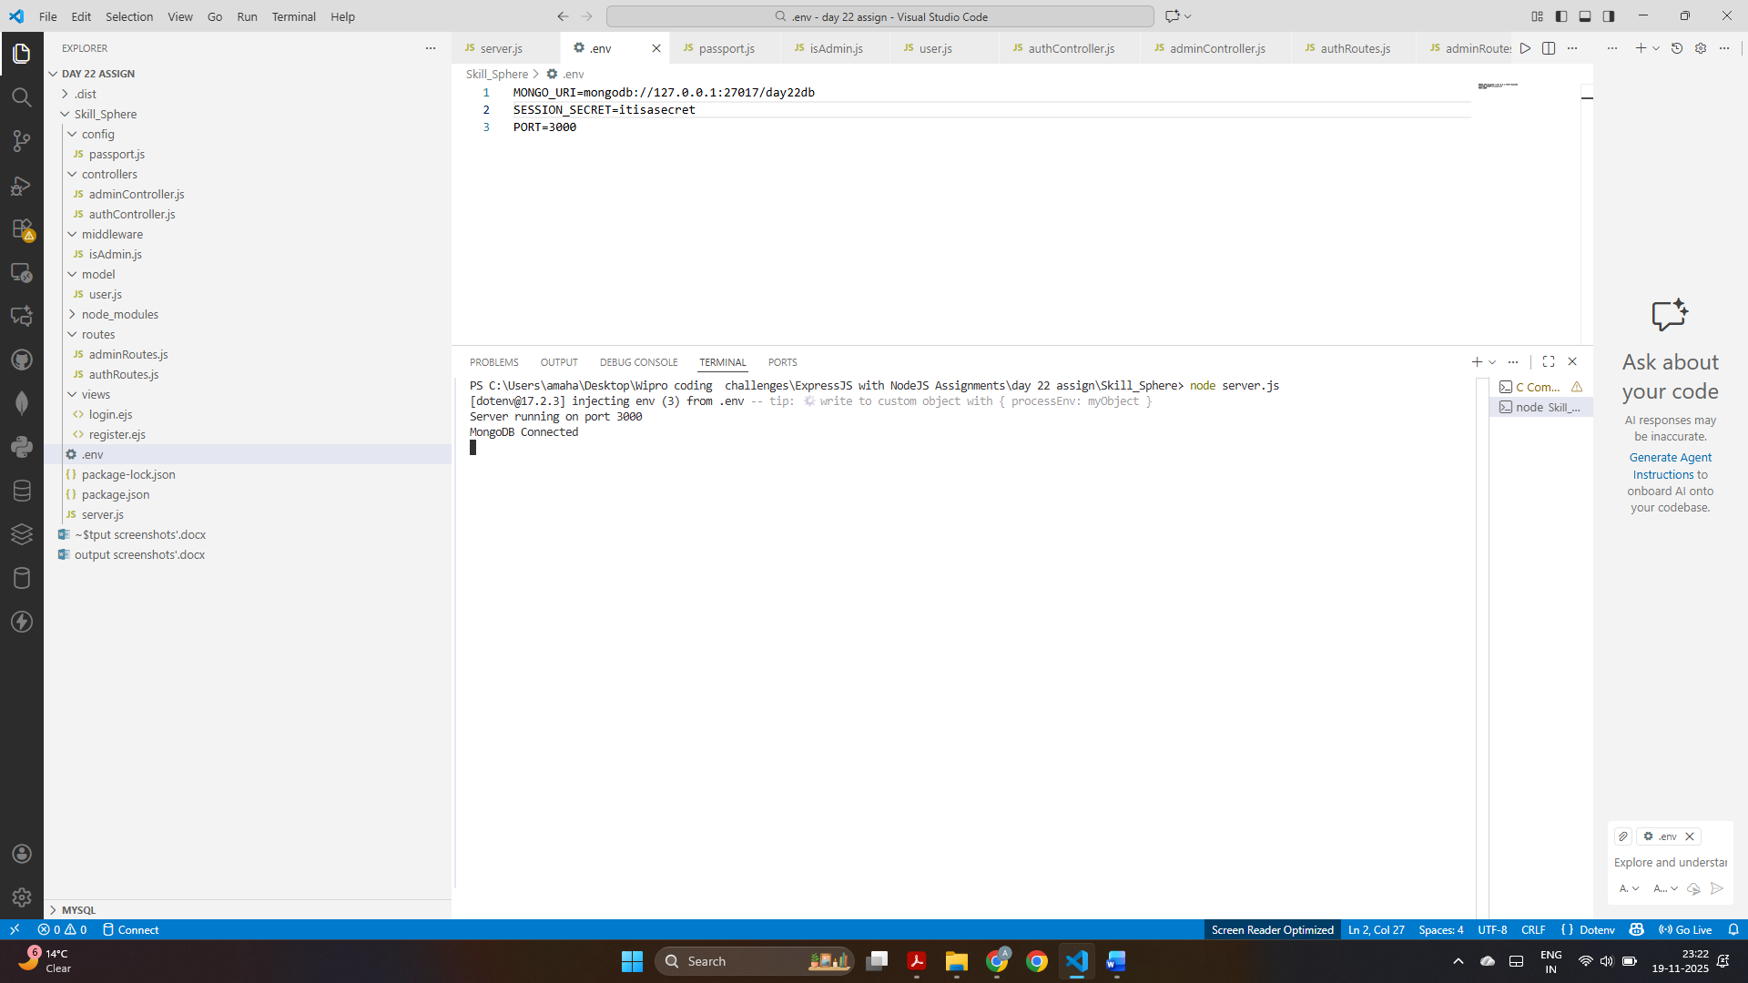
The terminal output shows that MongoDB connected successfully and the Node.js server is running on port 3000.

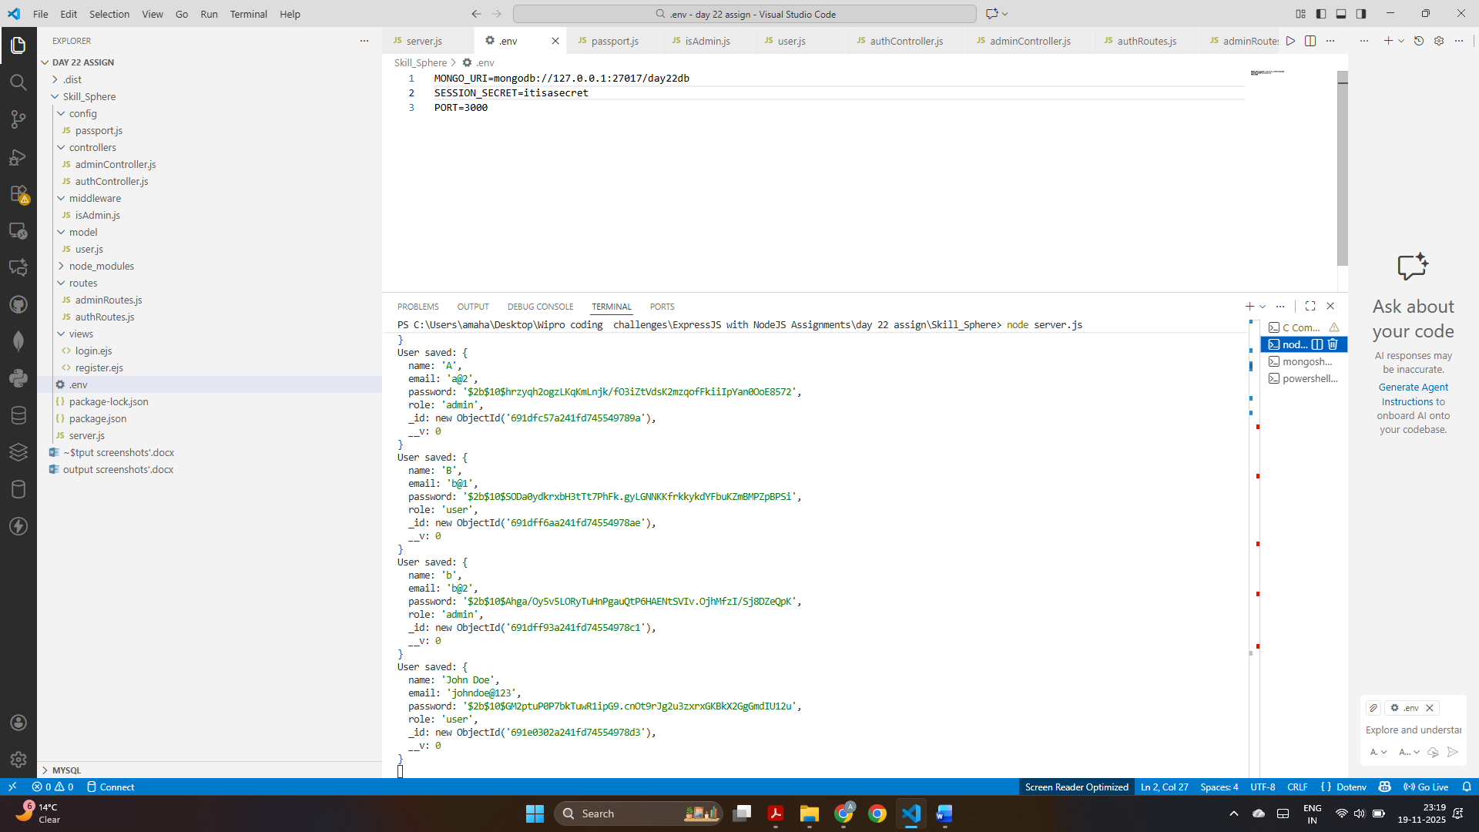
This screenshot displays console output with multiple user objects saved in the database using bcrypt-hashed passwords, indicating successful backend registration operations.

Challenge 3:
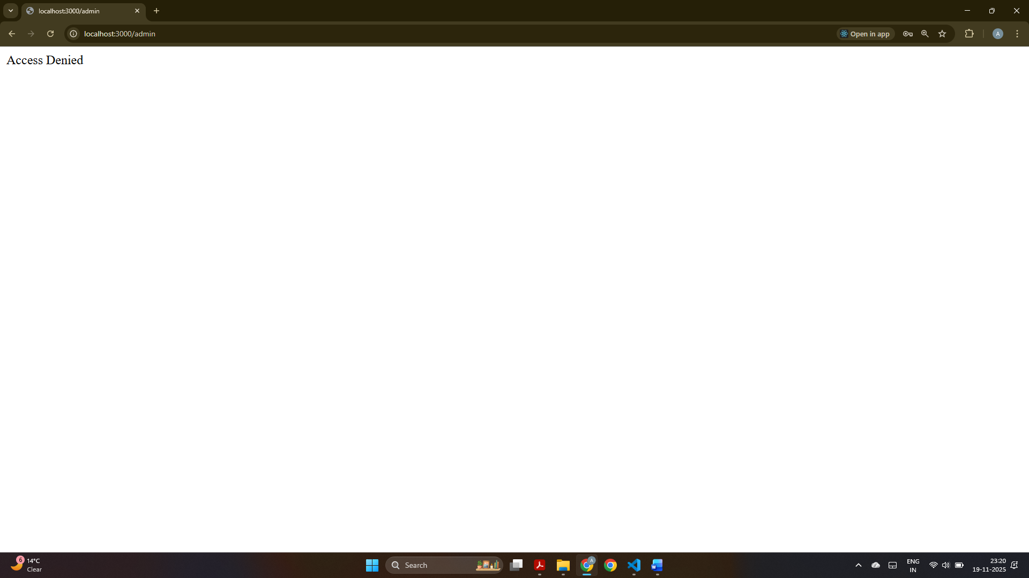
This screenshot displays “Access Denied,” meaning a normal user tried to access the /admin route but lacked admin privileges.

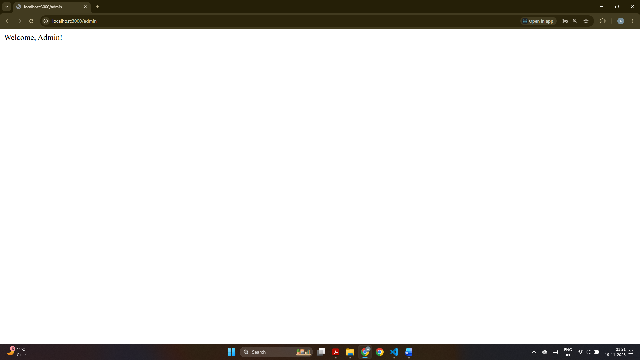
This confirms successful admin login, an admin tried login instead of a normal user, showing the message “Welcome, Admin!” after redirecting to the admin route.

